**NIRMA UNIVERSITY**

**INSTITUE OF TECHNOLOGY**

**MECHANICAL ENGINEERING**

**Programmable logic controller (PLC)**

**LAB – 10**

**19BME134**

**Shrey Shah**

**Aim**

To design small control system using PLC.

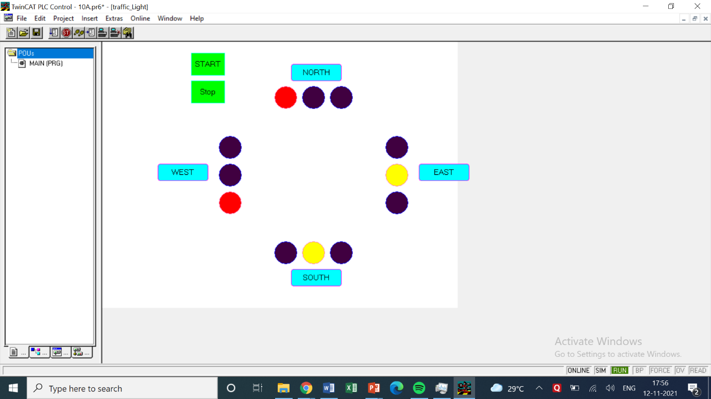

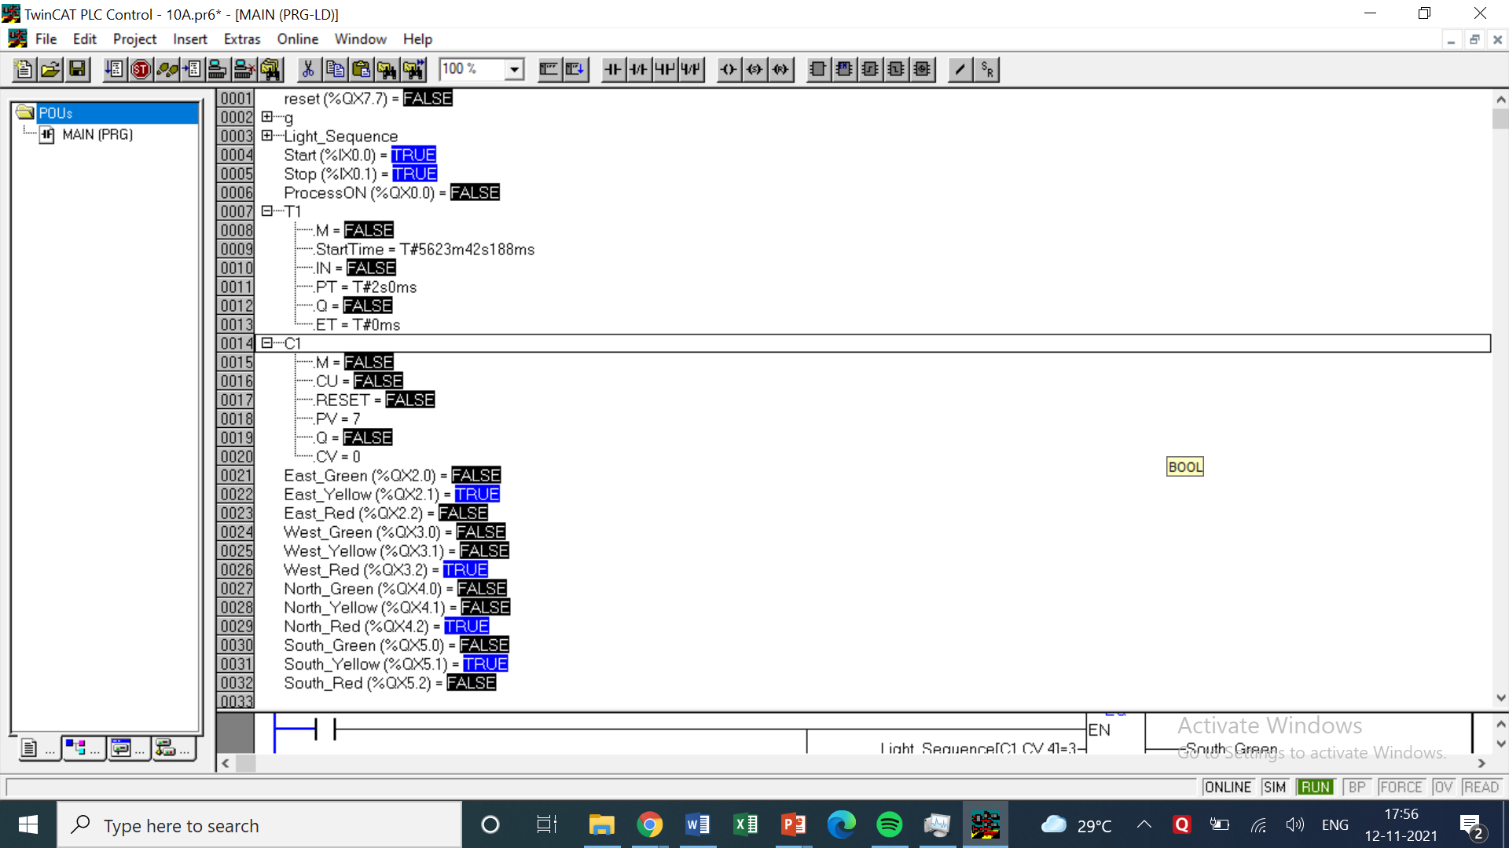

LOGIC -

* This experiment was a good one and interesting. Here in the first 2 rungs I added the basic star switch and in series with a stop switch to temporarily stop the process. After starting the process the process on light is turned on.
* In the 2nd rung the process on light is taken as input and connected to a timer and further in series with the output of timer. The Timer T1 has a delay time of 2 seconds for the sake of practical.
* The counter is connected in parallel to the output of timer so that it will count the pulse as well as not affect the overall circuit of the rung.
* After this 4 MAJOR rungs are taken each for North, East, West and South.
* The data sequence which is given in the question for the traffic sequence is inputted in an 2 dimensional array with the columns representing the directions and rows representing the order.
* In each particular iteration all the rungs of those directions will check the values stored in that particular row of the array.
* Green, Yellow and Red light have been abbreviated as the numbers 1, 2 and 3.
* The rungs of all directions which check what the current number for their direction is and give an output.
* Hence for this we can say there will be 12 function blocks and 12 outputs for 4 directions each checking 3 different light conditions.
* After the counter has reached 7 (from 0 to 7 i.e. 8), the reset output will be turned on and hence resetting the counter and the iteration.
* The counter value serves as an address to the (i)th row and 1,2,3,4 will be used to address the (j)th column.
* For this question I have prepared a working simulation too which actually looks good too but I can only submit the photo of the simulation for now along with the ladder logic instead of direct file.

|  |  |  |  |
| --- | --- | --- | --- |
| INPUT / OUTPUT | | INPUT / OUTPUT | |
| Start | %ix0.0 | South Green | %qx5.0 |
| Stop | %ix0.1 | South Yellow | %qx5.1 |
| East Green | %qx2.0 | South Red | %qx5.2 |
| East Yellow | %qx2.1 | Reset | %qx7.7 |
| East Red | %qx2.2 | Process ON | %qx0.0 |
| West Green | %qx3.0 | Timer T1 | Delay time = 2 sec |
| West Yellow | %qx3.1 | Counter C1 | Preset Value = 8 |
| West Red | %qx3.2 | North Green | %qx4.0 |
| - | - | North Yellow | %qx4.1 |
| - | - | North Red | %qx4.2 |
| Light Sequence: ARRAY [0..7,1..4] OF INT := 1,3,3,3,2,3,2,3,3,3,1,3,3,2,2,3,3,1,3,3,3,2,3,2,3,3,3,1,2,3,3,2; | | | |

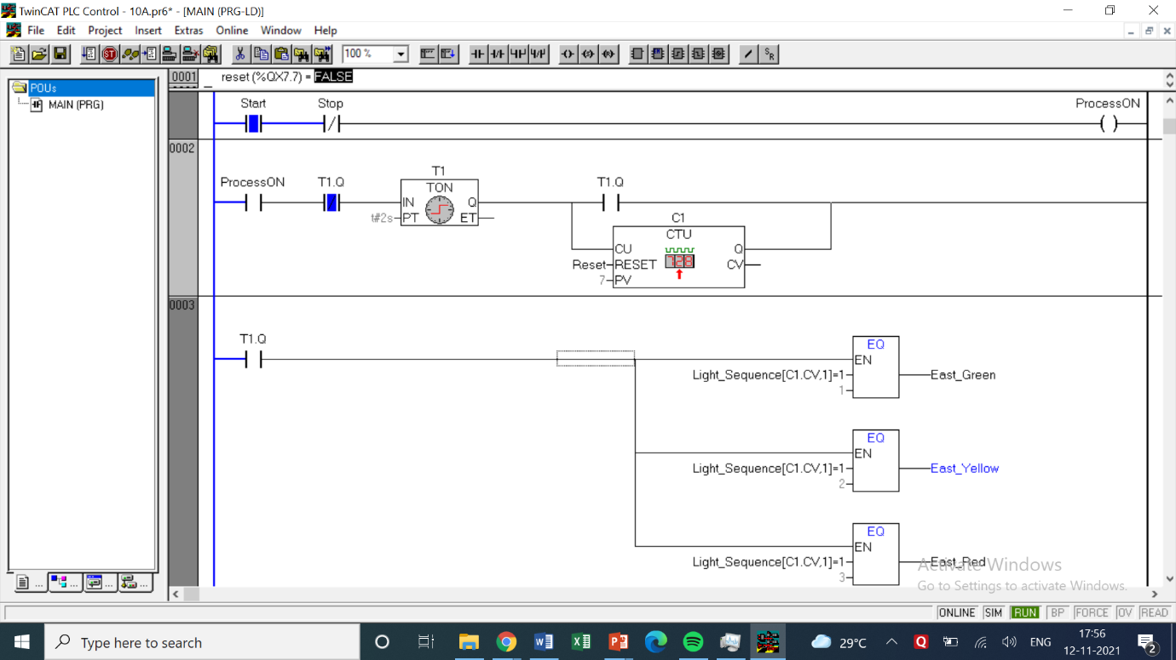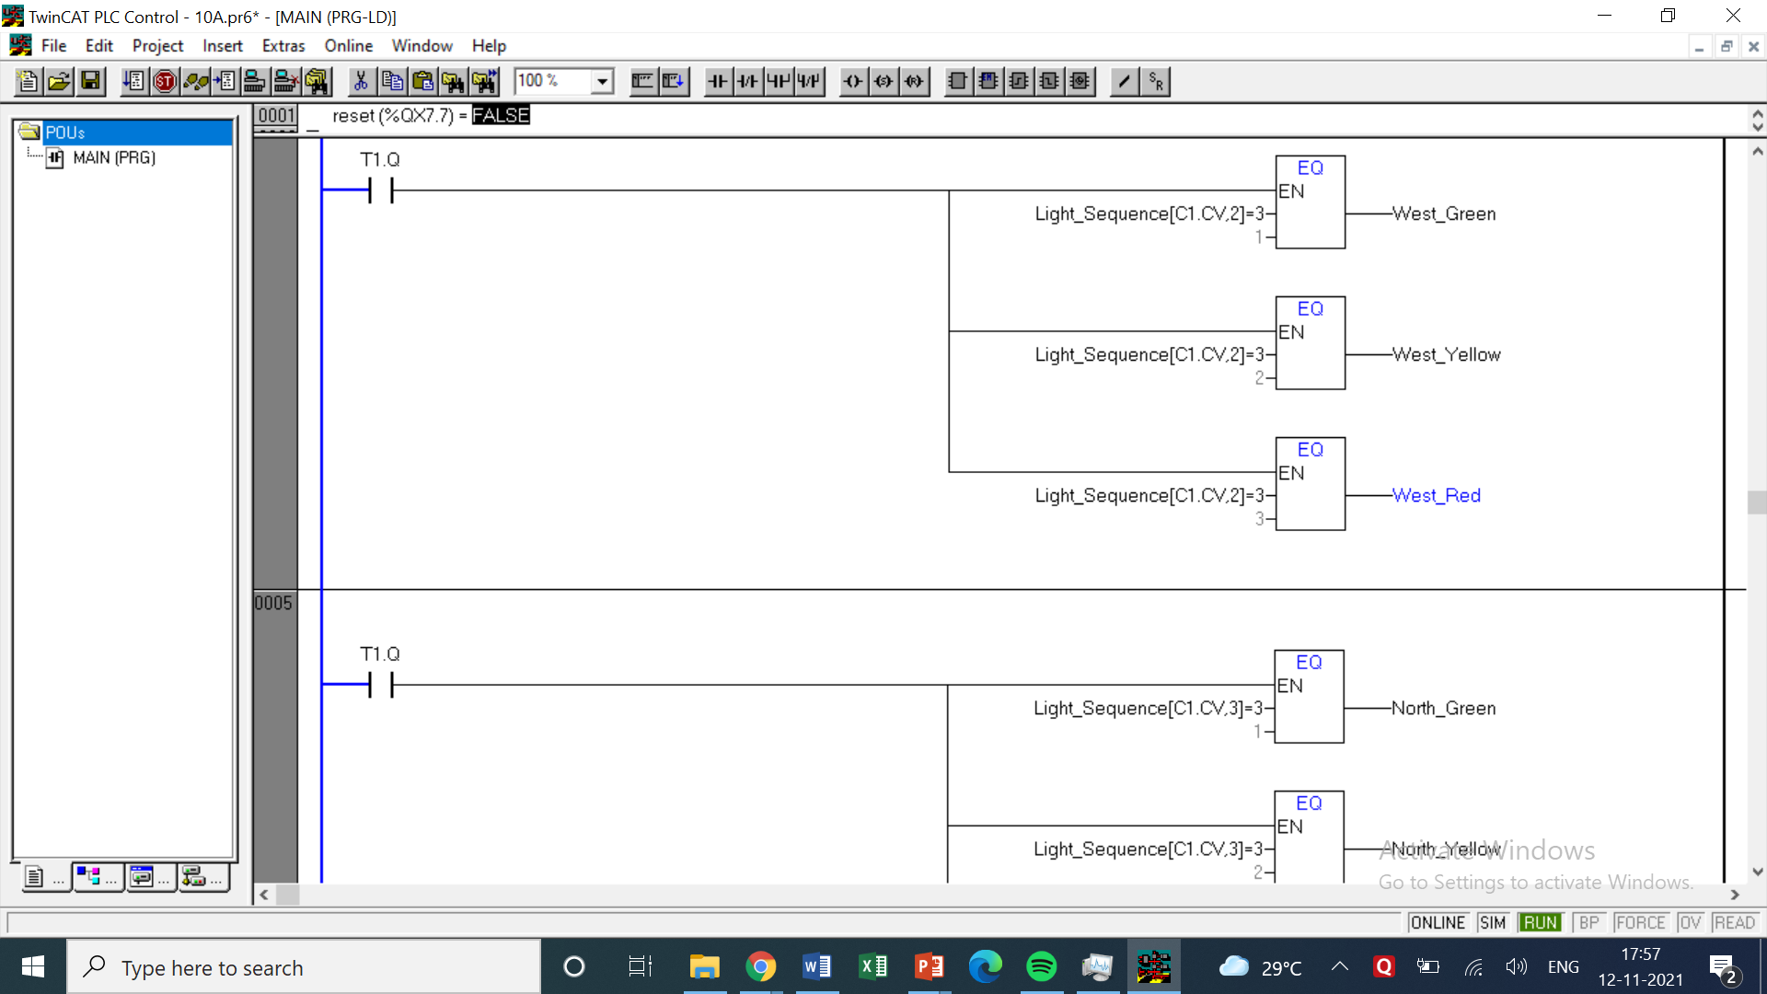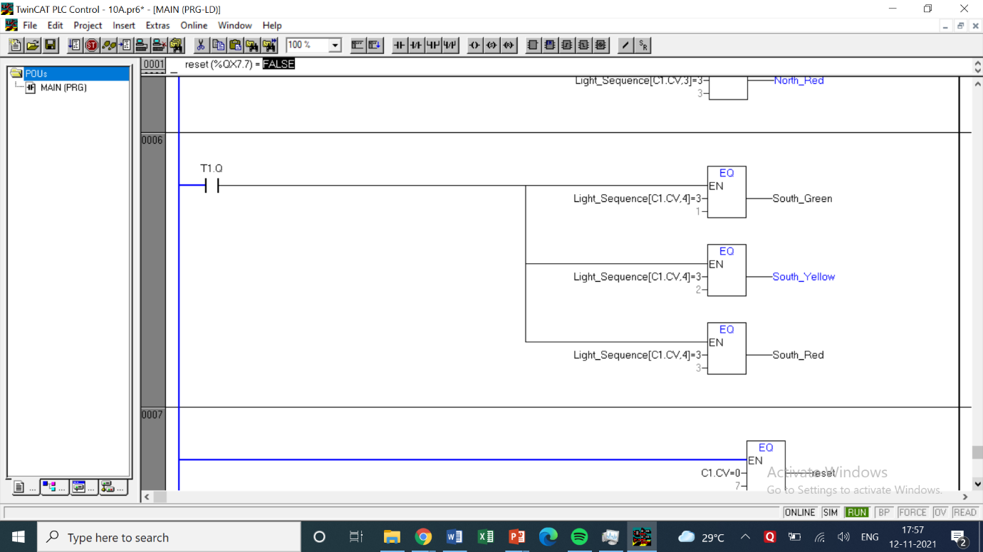

COMMENTS –

* The counters in most of the questions are denoted by the letter ‘C’ followed by the number of the counter or the letter.
* In case of UP and DOWN timers their names have been specified while mentioning the use of counters. Cn.q represents the output of those counters which may be taken as NO or NC switches.
* Each question has a table of inputs and outputs which specifies which I/Os have been taken along with its addresses.
* All the timers are generally denoted by the symbol ‘tn’ where n represents the number of the timer.
* tn.q represents the output of the timer tn which can be both normally open or normally closed depending on how it is used based on the question’s requirements.

**Conclusion**

This experiment introduced me to the concept of arrays which wasn’t used in the past experiments. The counter was used to access that particular array and the rungs were used to check the values of the columns of that array. After creating the program a simulation was made and concluded that traffic lights is a very good application for PLC to be used in.